**PRACTICAL – 3 (3.1)**

**AIM:**

**Take two lists, a = [1, 1, 2, 3, 5, 8, 13, 21, 34, 55, 89], b = [1, 2, 3, 4, 5, 6, 7, 8, 9, 10, 11, 12, 13] and write a program that returns a list that contains only the elements that are common between the lists (without duplicates). Make sure your program works on two lists of different sizes.**

|  |
| --- |
|  |

**PROGRAM:**

|  |
| --- |
| a = [1, 1, 2, 3, 5, 8, 13, 21, 34, 55, 89]  b = [1, 2, 3, 4, 5, 6, 7, 8, 9, 10, 11, 12, 13]  common = []  a = set(a)  b = set(b)  for i in a:  if i in b:  common.append(i)  print(common)  print("\n20DCE019 - Yatharth Chauhan") |

**OUTPUT:**

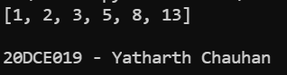

**CONCLUSION:** In this practical we learned about the usage of set.

**PRACTICAL – (3.2)**

**AIM:**

**Write a program by asking the user for a string and print out whether this string is a palindrome or not. (A palindrome is a string that reads the same forwards and backwards.)**

|  |
| --- |
|  |

**PROGRAM:**

|  |
| --- |
| string = input(("Enter a string: "))  if(string == string[::-1]):  print("String is a palindrome")  else:  print("String is not a palindrome")  print("\n20DCE019 - Yatharth Chauhan") |

**OUTPUT:**

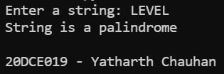

**CONCLUSION:** In this practical we learned about the palindrome.